**Today’s Report 26-01-2021**

***Creating by : HAS Coding***

This report contais details of Wireframe to HTML :

* Installation of Xampp
* Create some folders and named « Starter »
* Using Git clone to save the files of C1C2_N1N2
* Open the code HTML in VS Code and analyse it and notice that the most used in the code are tag Link, div and tag h3, also been noticing that there’s no header.
* Comparing the section of my experience With the wireframe that was created by the team and notice that there’s some icons in the code HTML
* Improve the wireframe that was created by team HAS coding depending on the creativity of the team, also adding the tag of HTML.

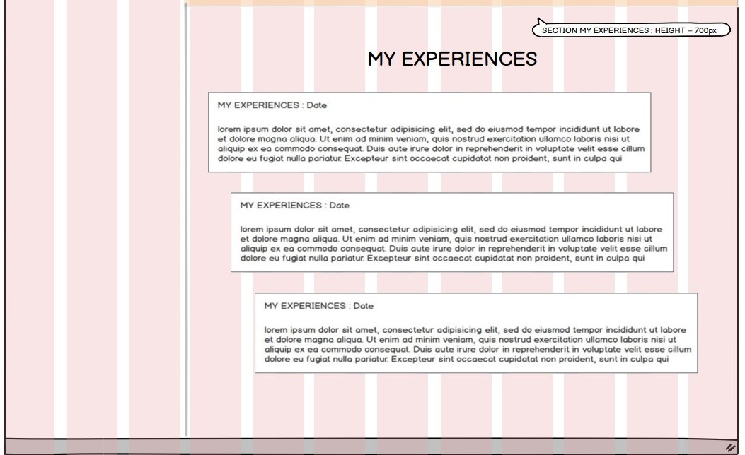

Figure : Old section of my experience

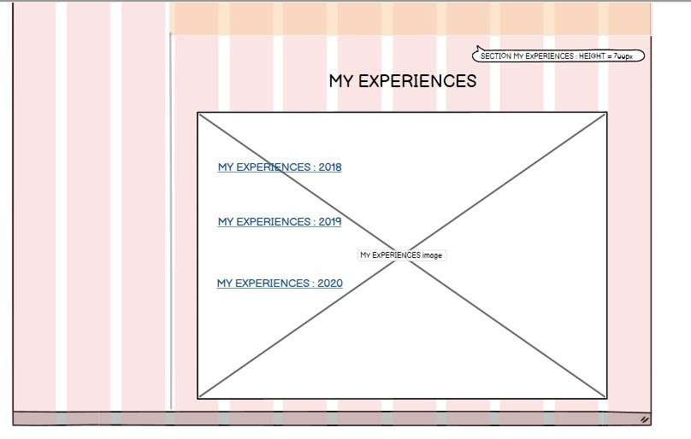

Figure The new section of my experince